**FIRST CHALLENGES**

1. Launch one ec2 instance using amazon linux 2.

**Launch Amazon Linux 2 EC2 Instance**

1. **Sign in to your AWS Console.**
2. Navigate to **EC2** under the "Compute" section.
3. Click **Launch Instance**.
4. Enter an instance name and select **Amazon Linux 2** as the Amazon Machine Image (AMI).
5. Choose the **t2.micro** type for free tier.
6. Configure storage and security group (make sure to allow ports 22, 80, 8080).
7. Launch the instance and connect using SSH with your key pair

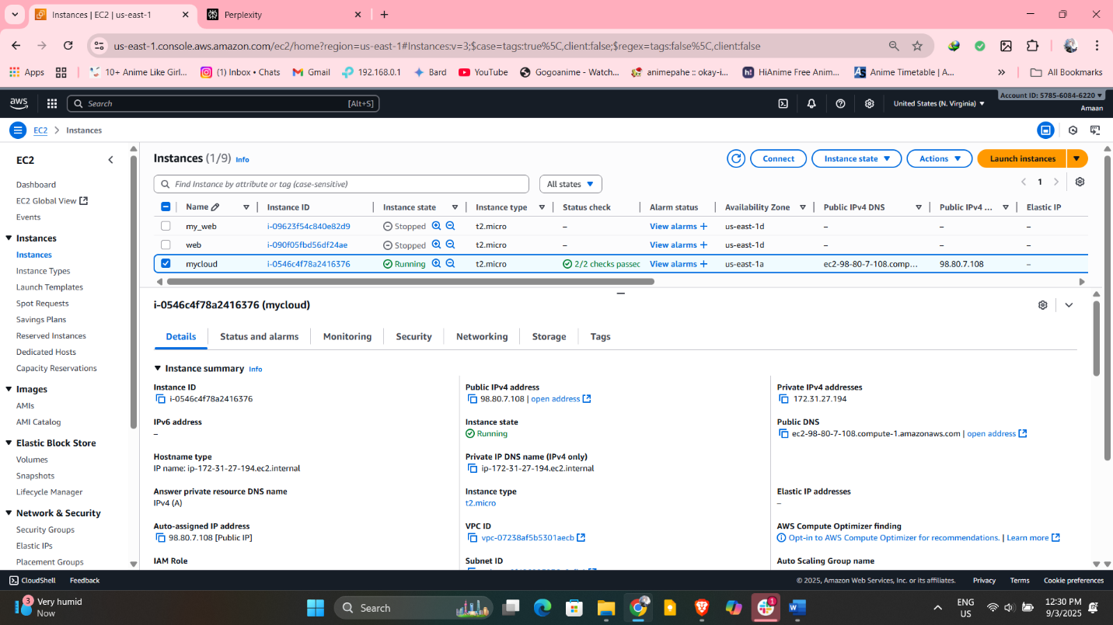

1. Install Docker

Run these commands after connecting via SSH:

text

sudo yum update -y

sudo amazon-linux-extras install docker -y

sudo systemctl enable docker

sudo systemctl start docker

sudo usermod -a -G docker ec2-user

Log out and back in to refresh group membership

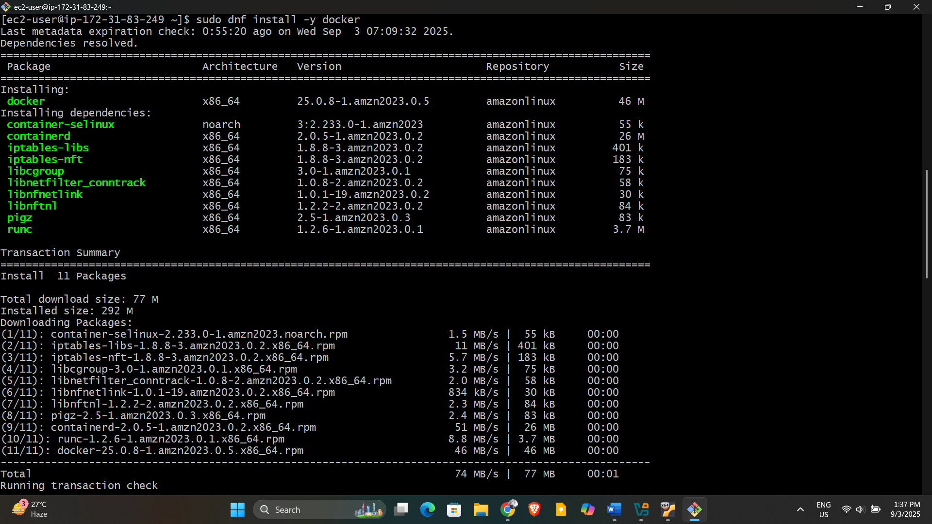

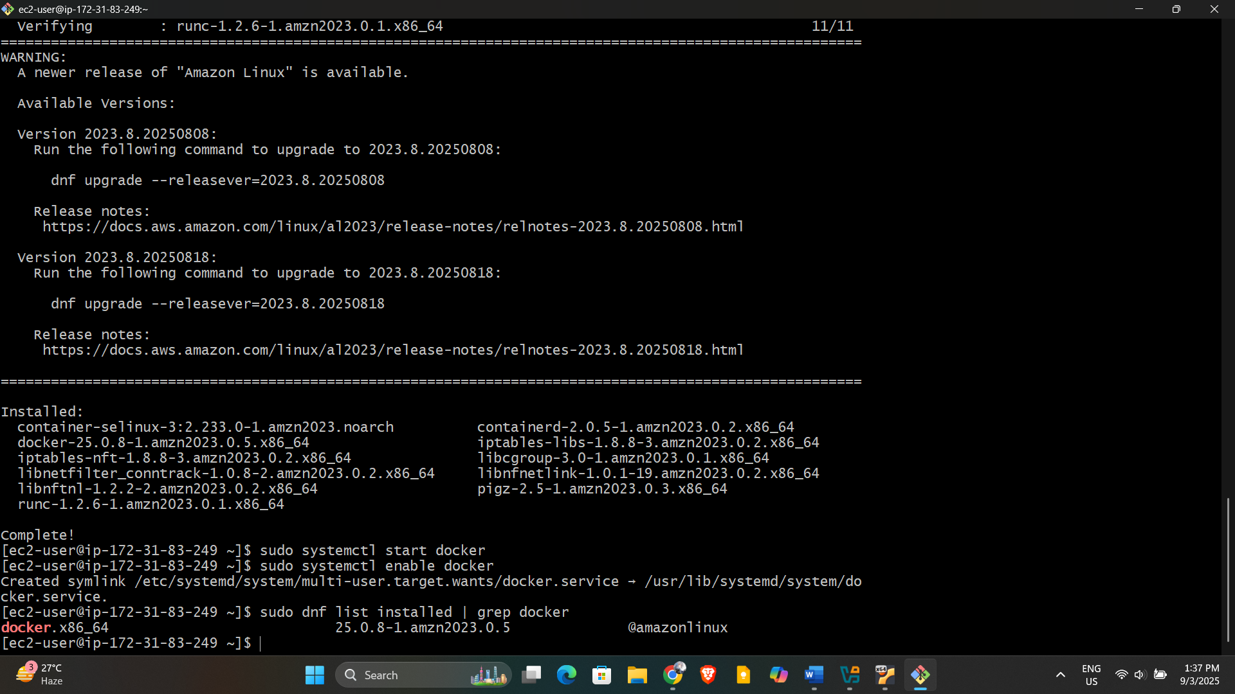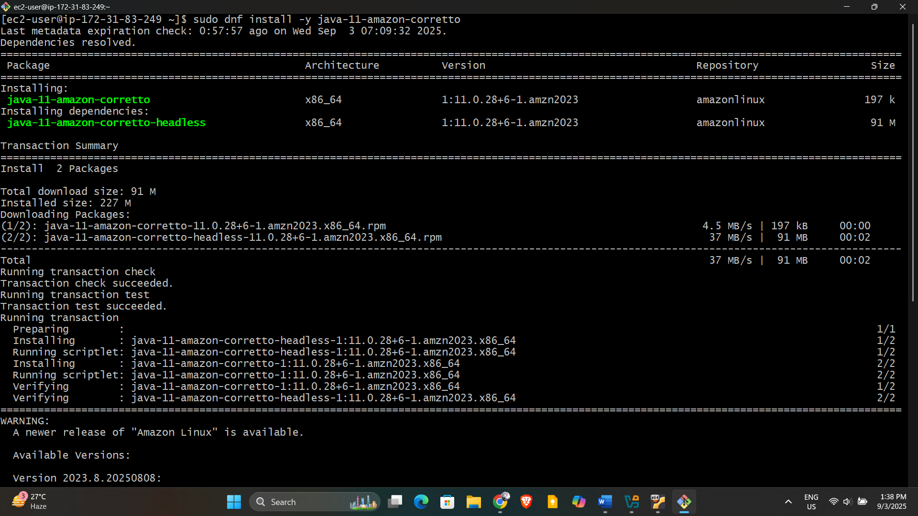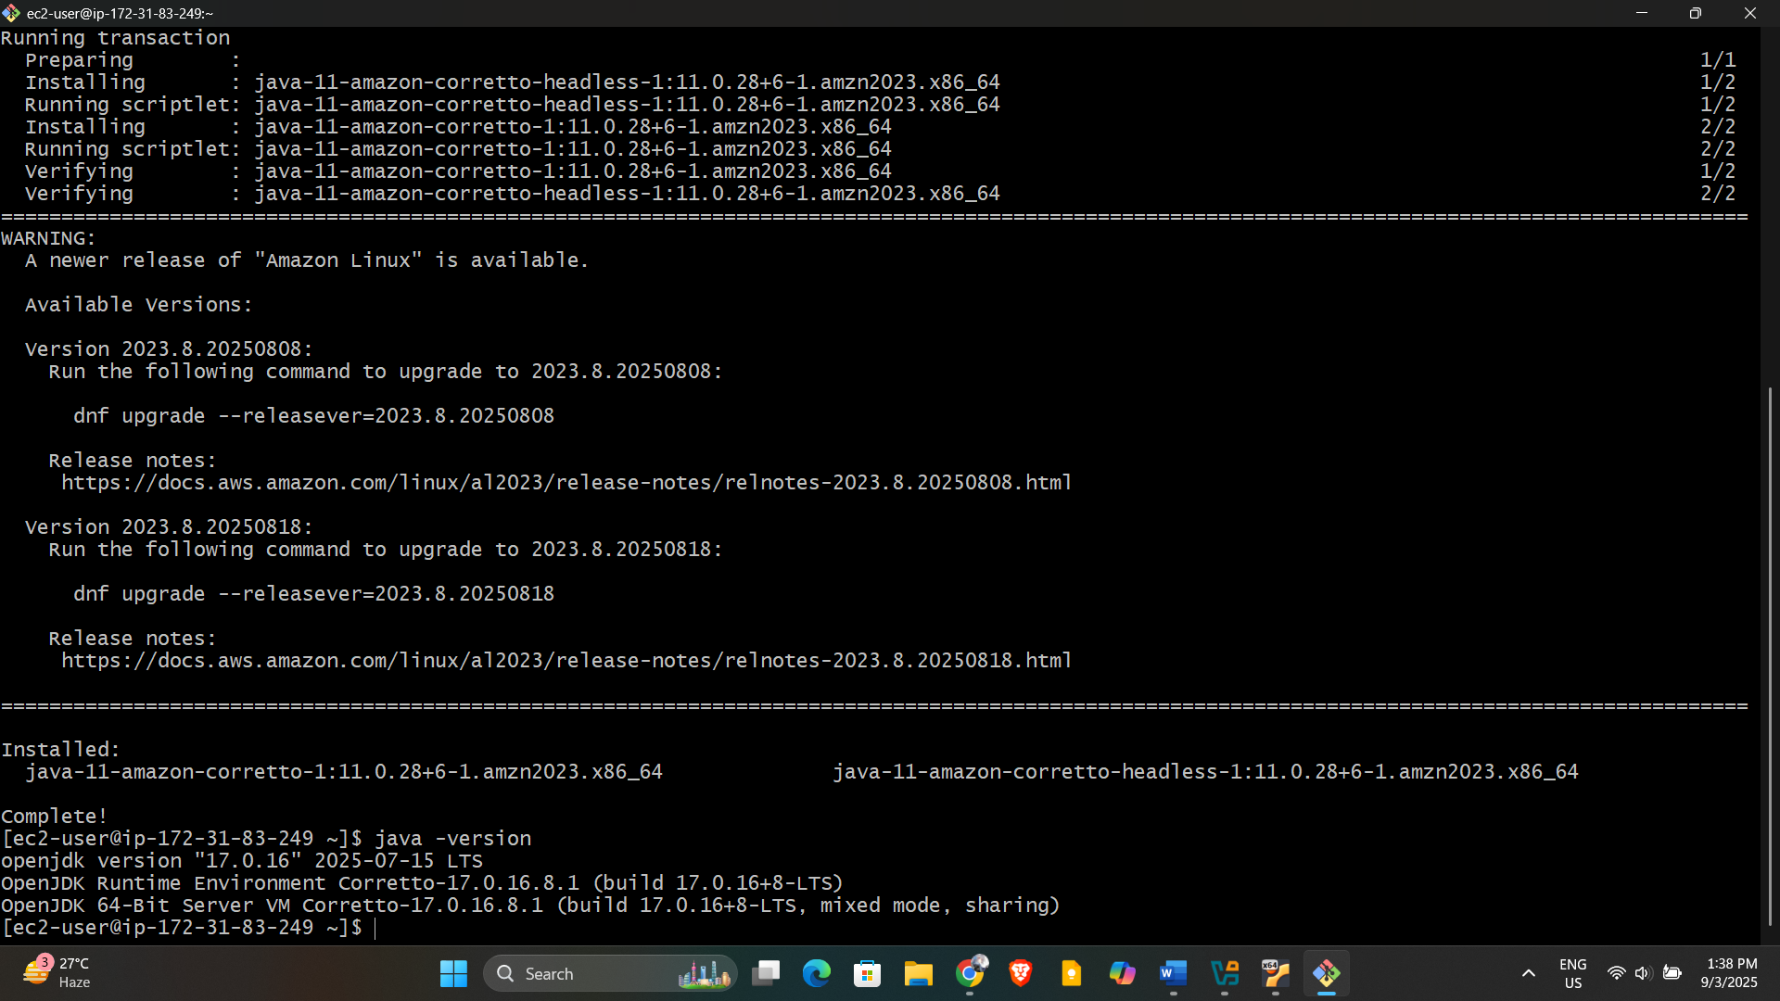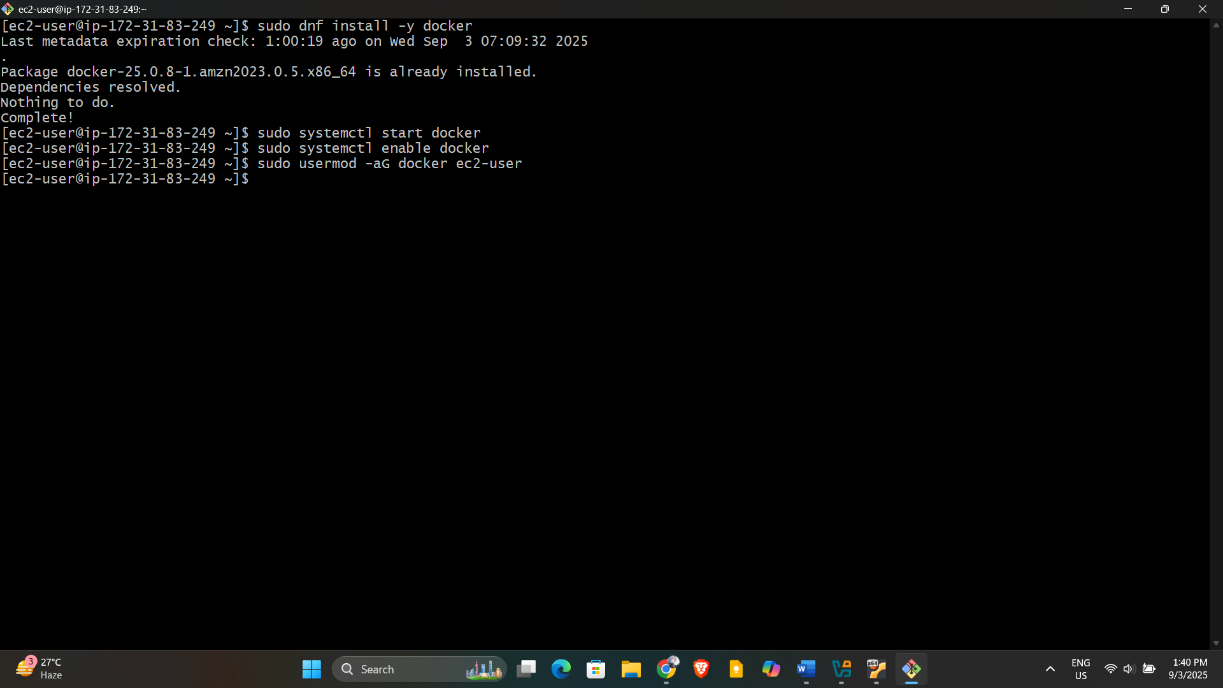

1. Install jenkins
2. Install Java (Jenkins requires Java 11+):

text

sudo amazon-linux-extras install java-openjdk11 -y

1. Add Jenkins repo and install Jenkins:

text

sudo wget -O /etc/yum.repos.d/jenkins.repo https://pkg.jenkins.io/redhat-stable/jenkins.repo

sudo rpm --import https://pkg.jenkins.io/redhat-stable/jenkins.io-2023.key

sudo yum install jenkins -y

1. Start Jenkins:

text

sudo systemctl enable jenkins

sudo systemctl start jenkins

Open port 8080 in your security group to access Jenkins.

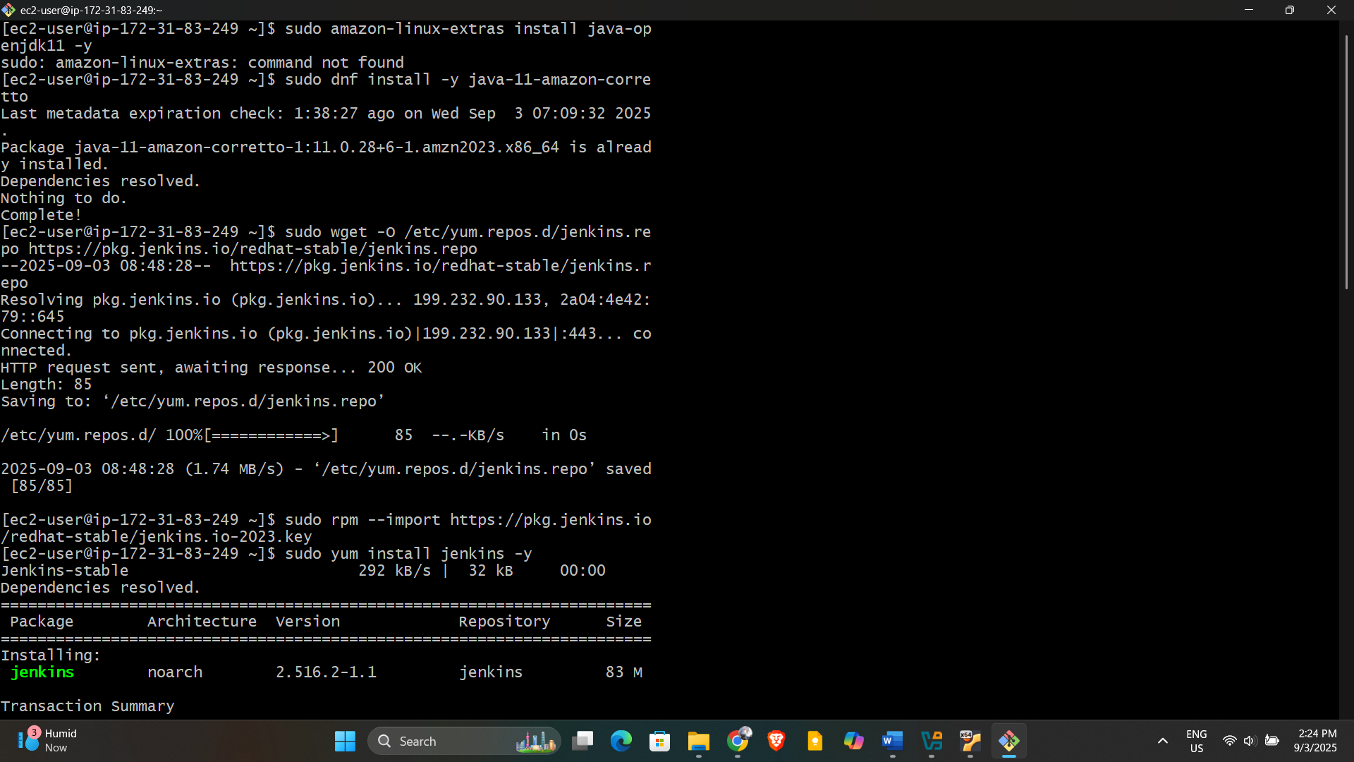

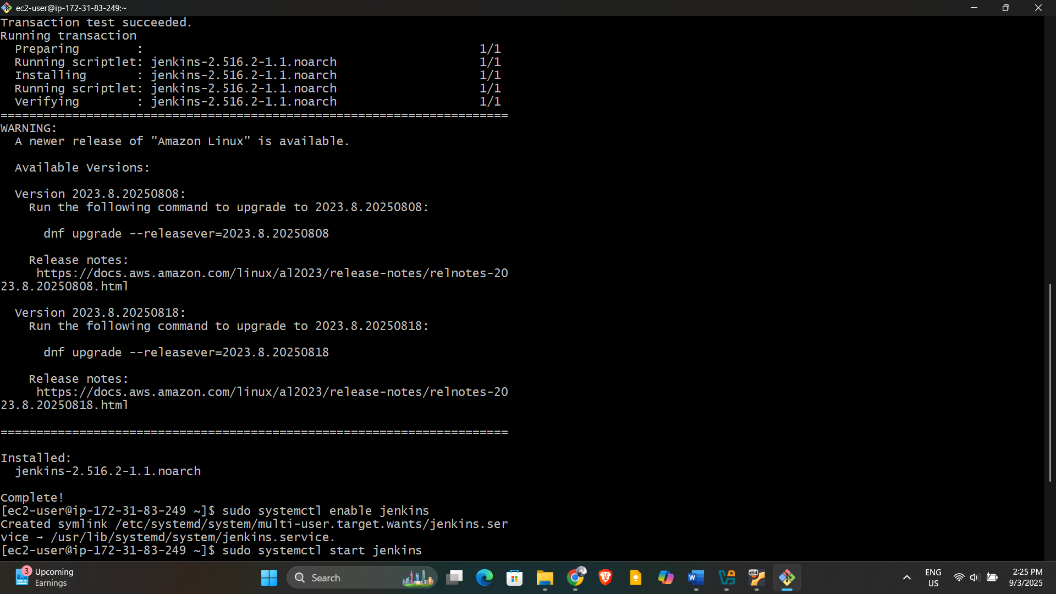

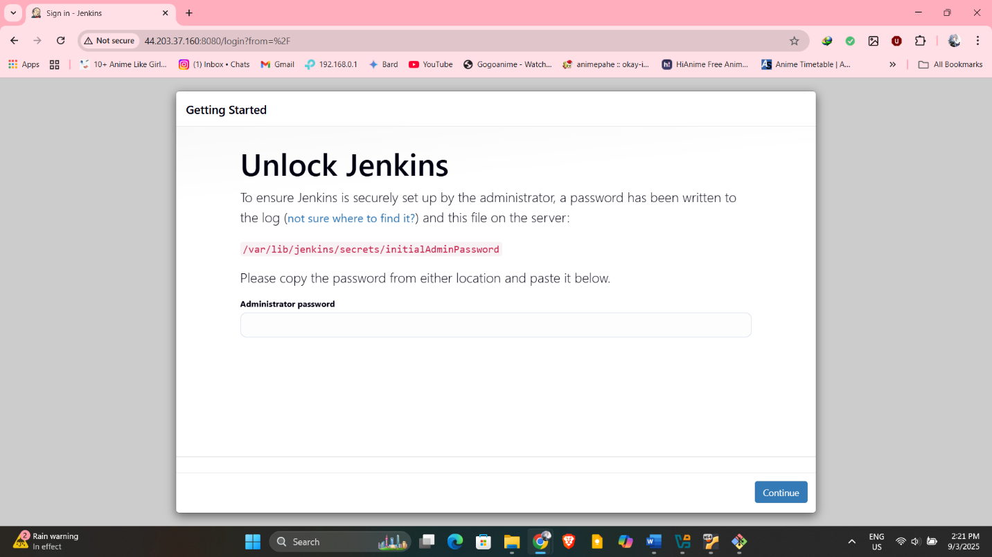

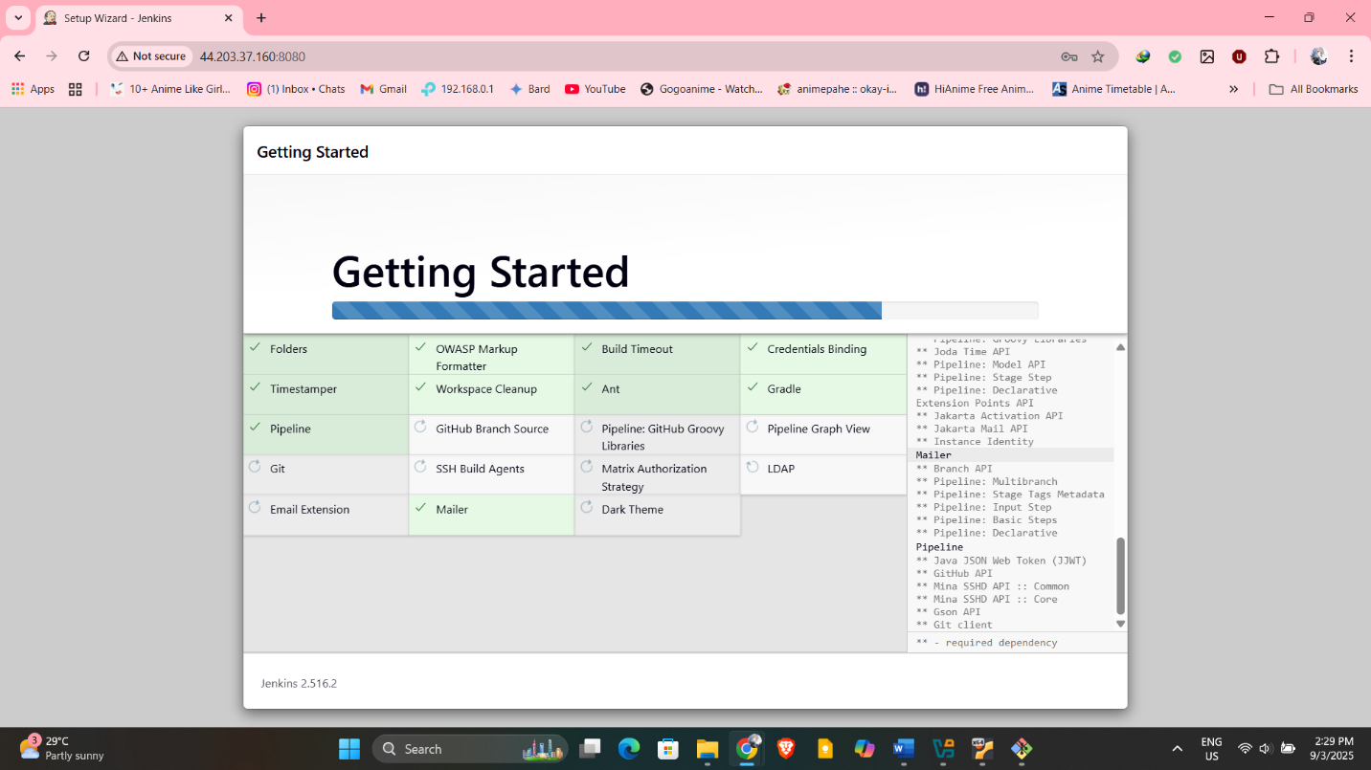

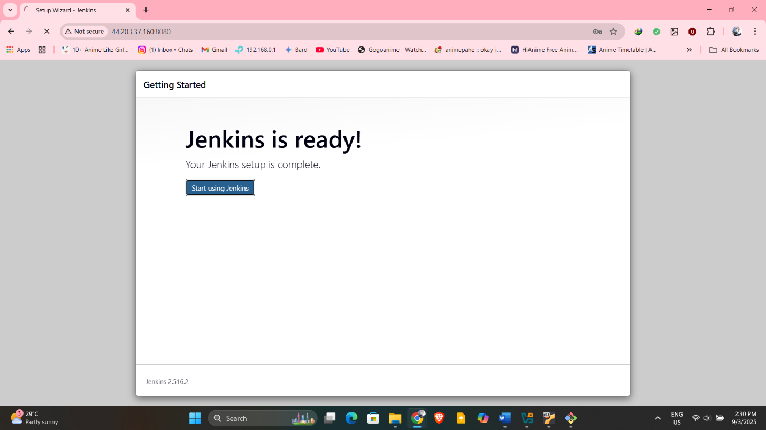

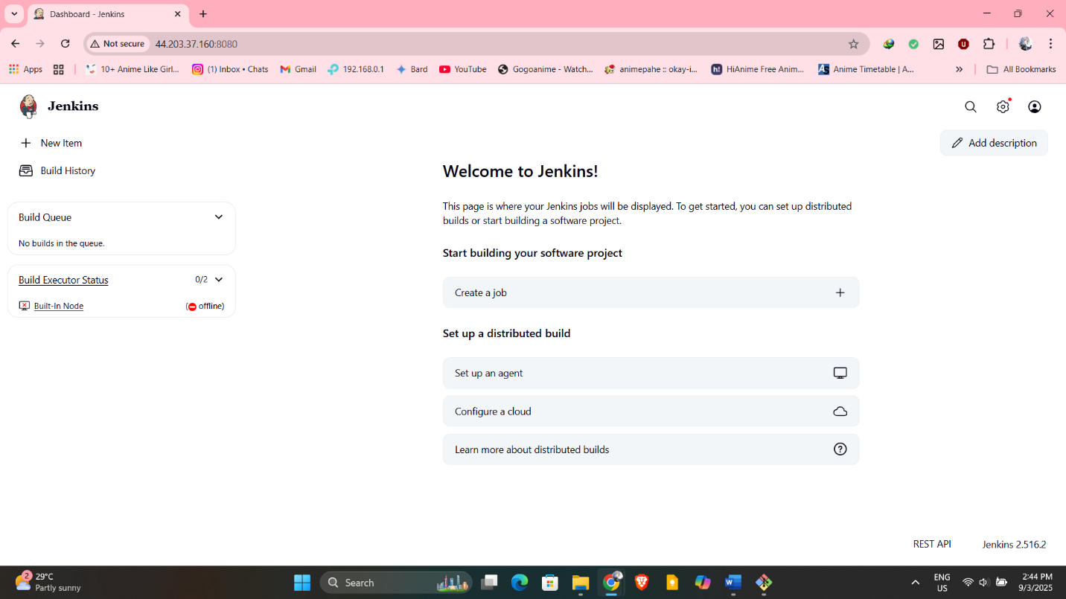

1. Install apache

Install Apache HTTP Server

text

sudo yum install httpd -y

sudo systemctl enable httpd

sudo systemctl start httpd

Open port 80 in your security group.

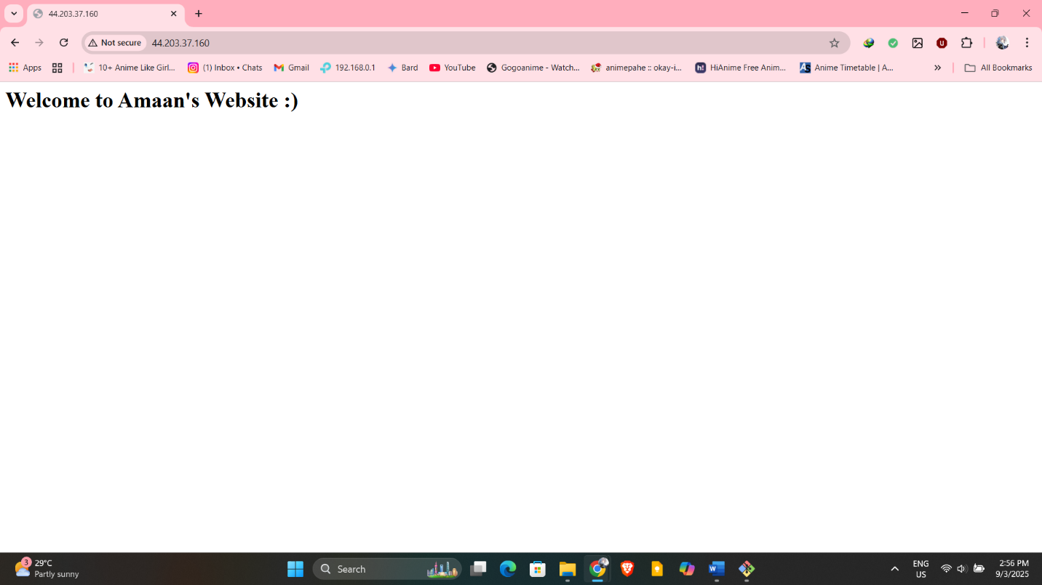

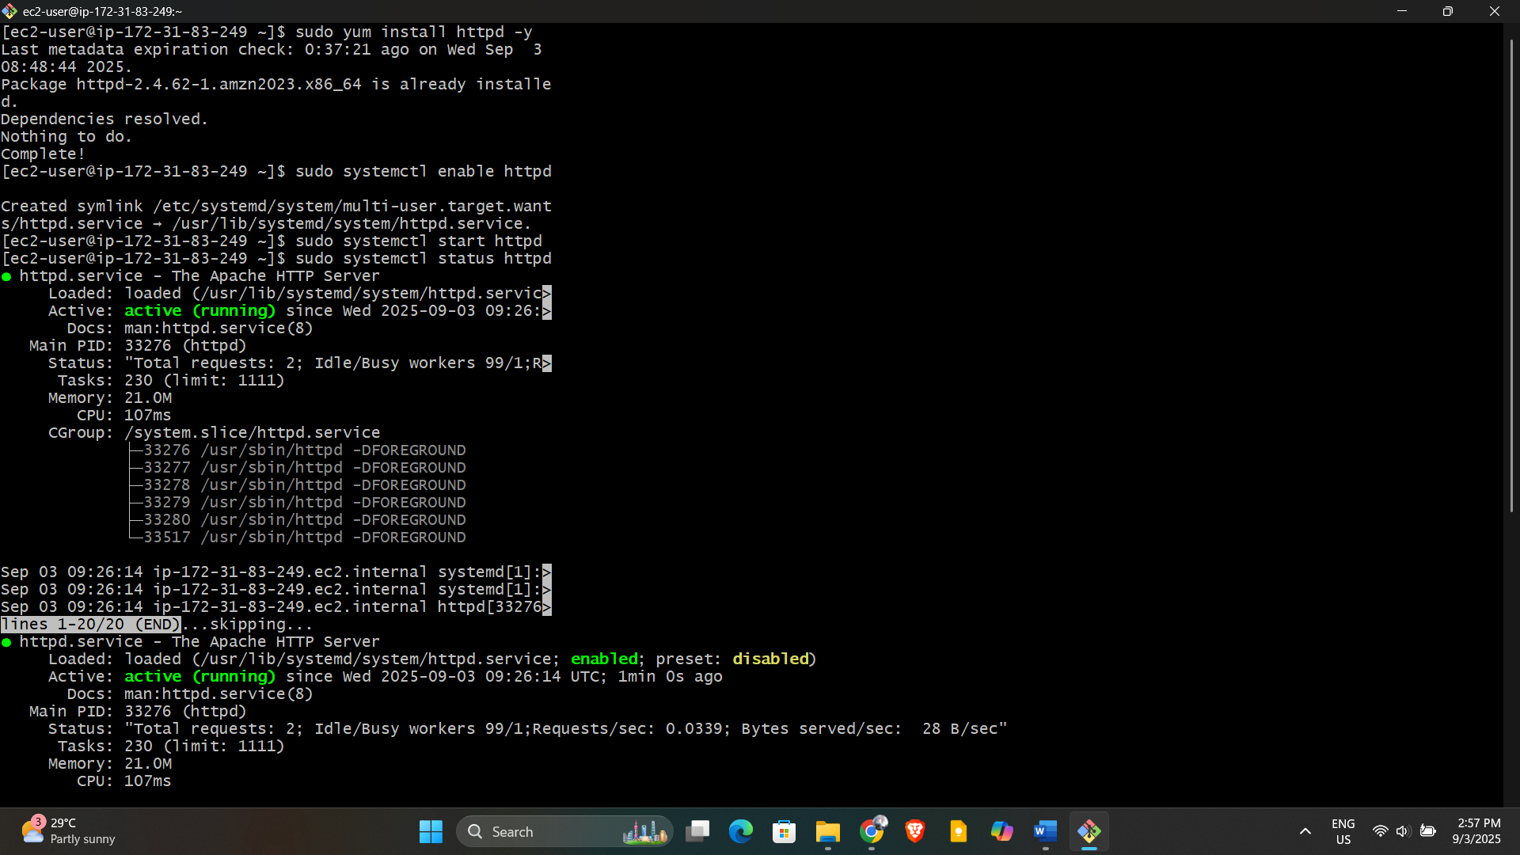

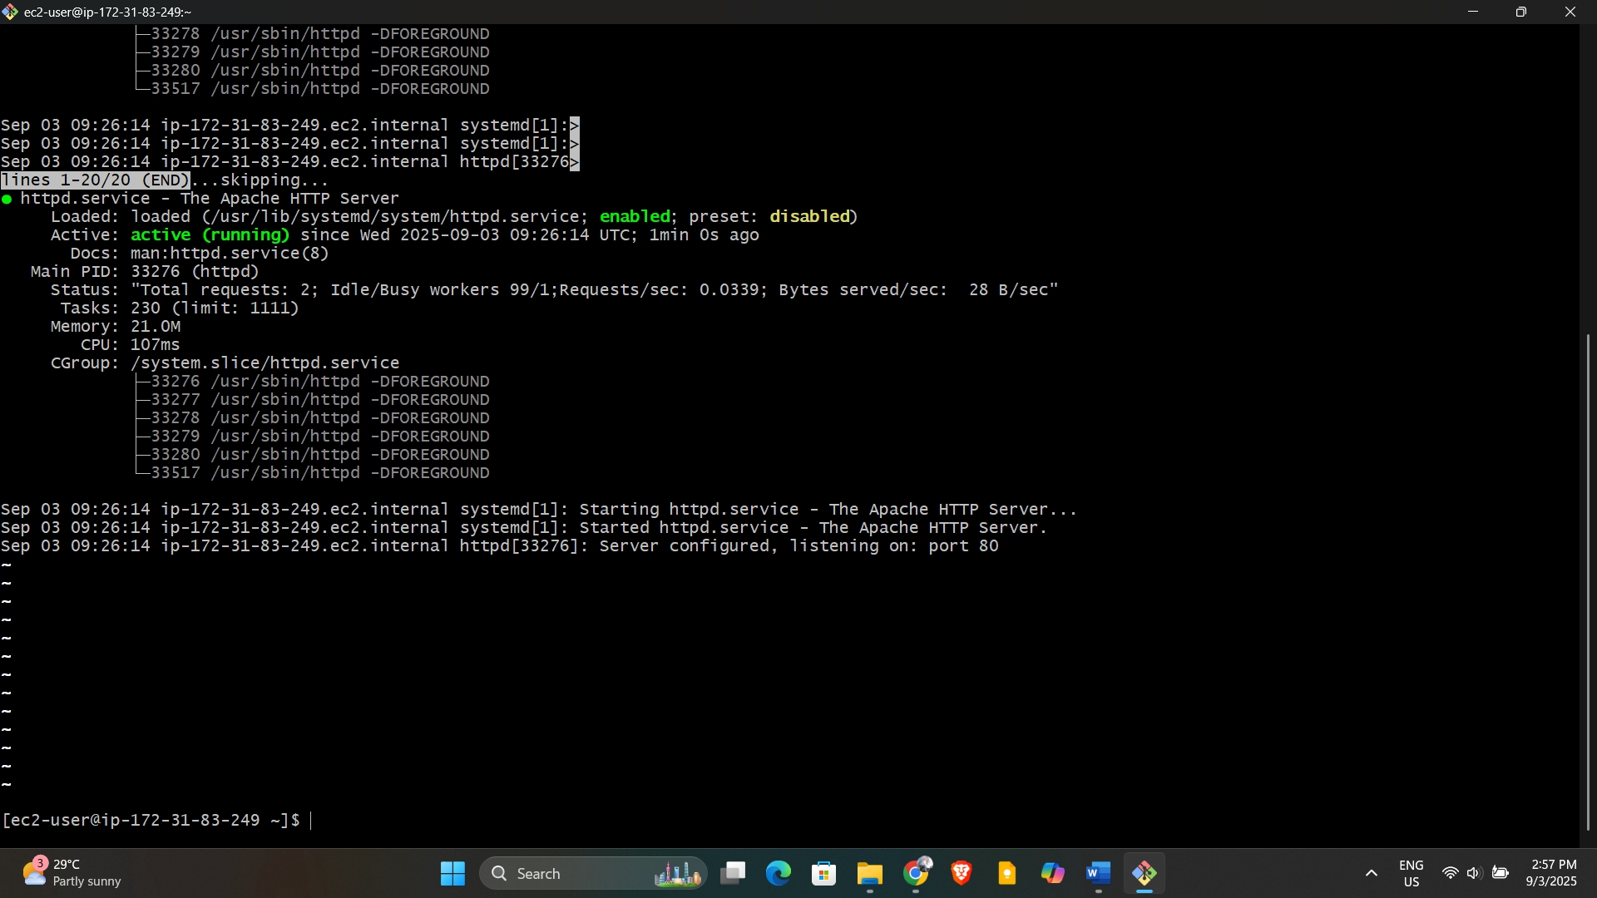

1. Install nginx

Install NGINX

text

sudo amazon-linux-extras install nginx1 -y

sudo systemctl enable nginx

sudo systemctl start nginx

NGINX is now installed and running.

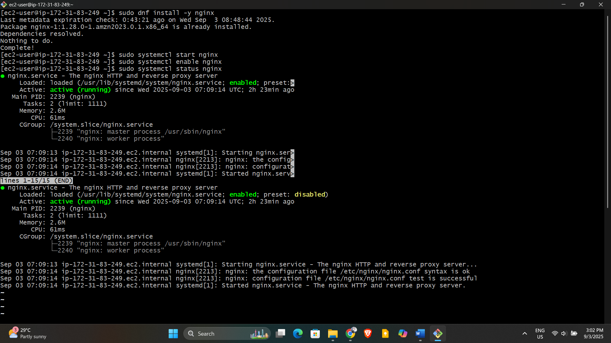

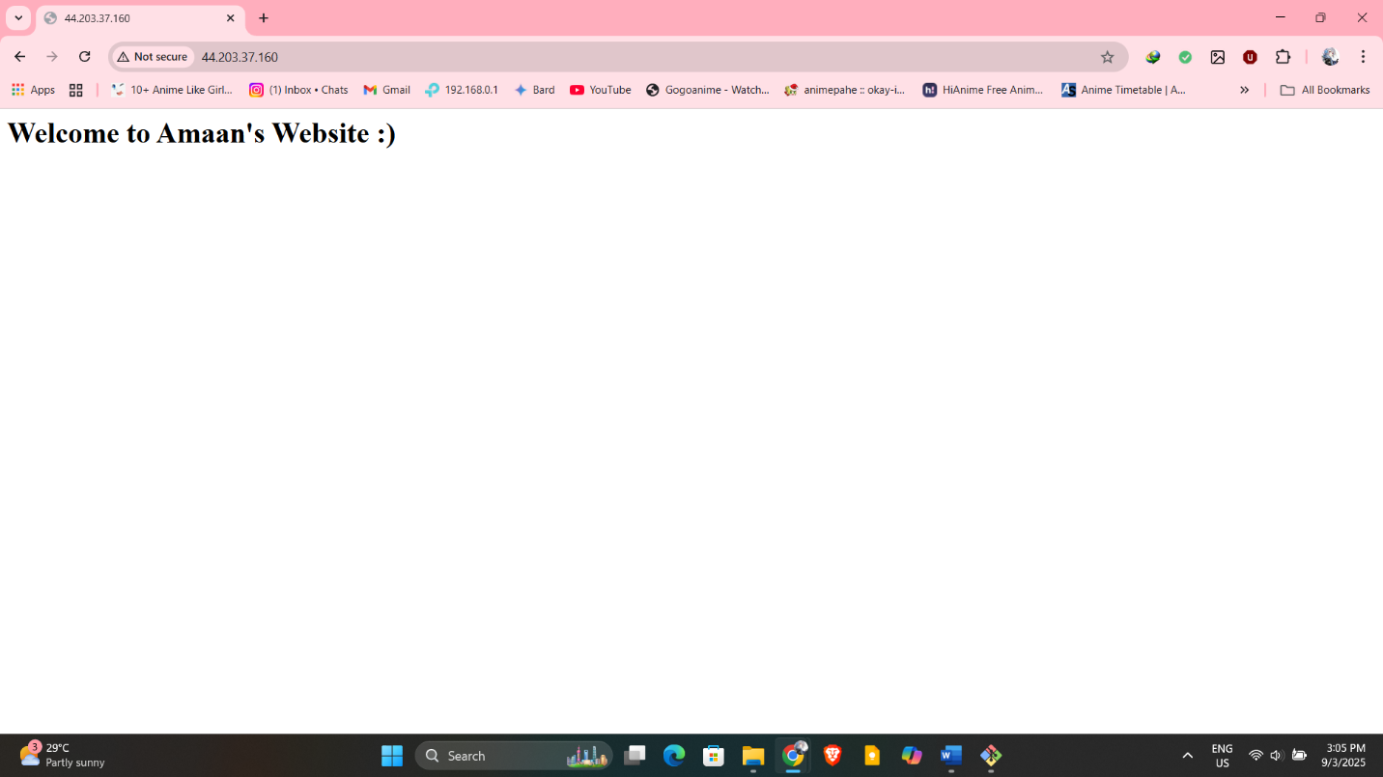

1. Install Apache Tomcat
2. Install wget and unzip (if not present):

text

sudo yum install wget unzip -y

1. Download and extract Tomcat:

text

cd /opt

sudo wget https://dlcdn.apache.org/tomcat/tomcat-9/v9.0.83/bin/apache-tomcat-9.0.83.tar.gz

sudo tar -xvzf apache-tomcat-9.0.83.tar.gz

sudo mv apache-tomcat-9.0.83 tomcat9

sudo sh /opt/tomcat9/bin/startup.sh

Open port 8080 in your security group to access Tomcat.

